Web Publishing: Single Document

Do you need to web publish a single document? This document will give you the instructions you need to accomplish this in Content Server.

This document will show you step by step how to web publish a document using the Content Server Web Browser access.

In this document you will learn about:
- How to navigate to your “Ready for Publishing” folder
- How to select your document’s category in the function menu
- Filling out the common and publishing categories
- How to choose an approver and select the “approval workflow”
- How to Publish a document

Step 1: Navigate to your “Ready For Publishing” folder
Navigate to your “Ready for Publishing” folder. This is a folder that has the categories necessary for web publishing.
The screenshot below shows a typical “Ready for Publishing” folder:

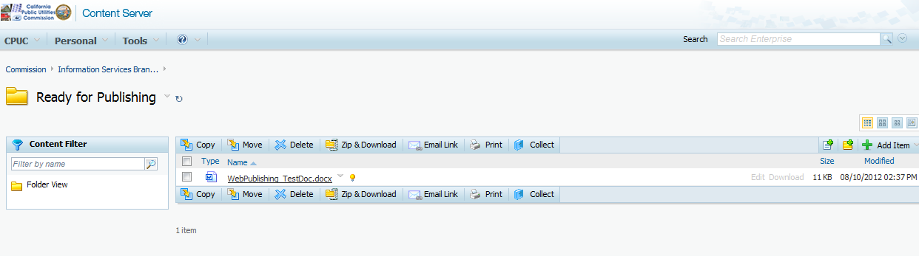

Step 2: Select “Categories” of the Document
From the function menu of the Document, select ‘Properties” and then “Categories”.
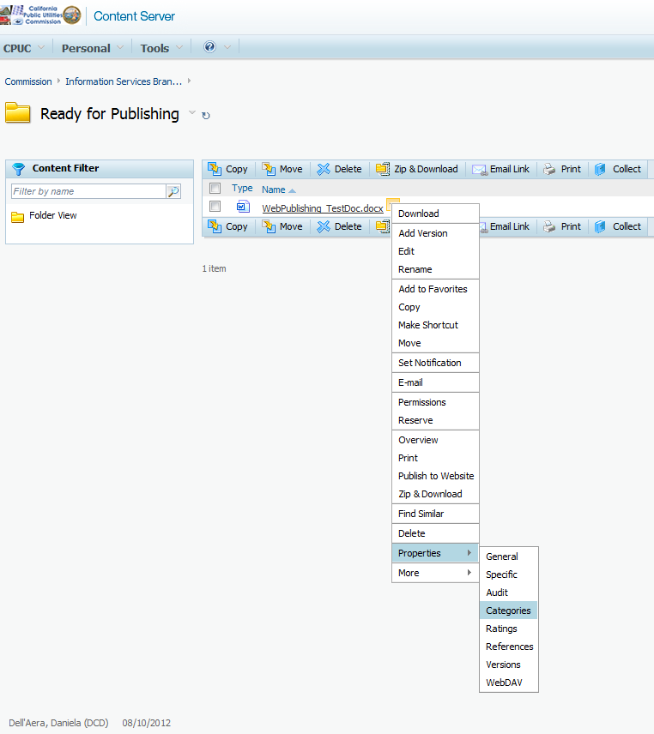

Step 3: Fill out the “Common” Category
Before showing you how to fill out the “Common” category, it is important to point out some preliminary information that will assist you on this process.

- The categories can be filled out a couple of different ways:
- You can either type the text yourself OR;
- You can pick a choice from the drop down list.

- The only required fields for web publishing are:
- Document Type and Industry located under the “Common” tab AND;
- Publishing Date under the “Publishing” tab.

- The only document types available for web publishing are:
- Agenda
- Daily Calendar
- Comment Decision
- Agenda Decision
- Final Decision
- General Order
- Item for legislative section of agenda
- News Release
- ORA Filings
- Report
- Agenda Resolution
- Comment Resolution
- Final Resolution
- Rules of Practice and Procedure

Given the preliminary information above, you are now ready to start filling out the information under the “Common” category:
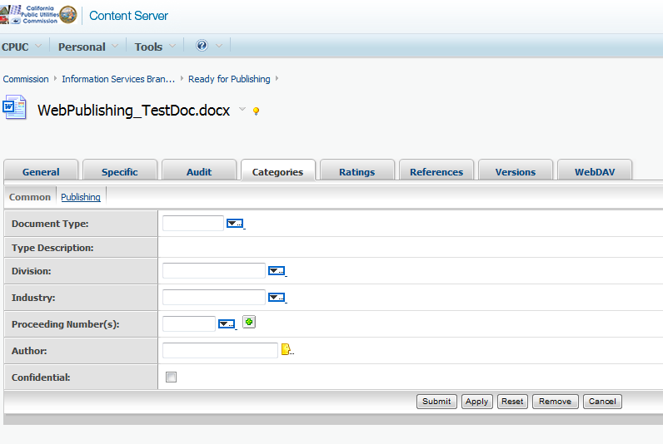

When entering Proceeding numbers (which is an optional field), you must type at least the first 3 characters of the proceeding number in order to perform the “lookup” in the drop down list.
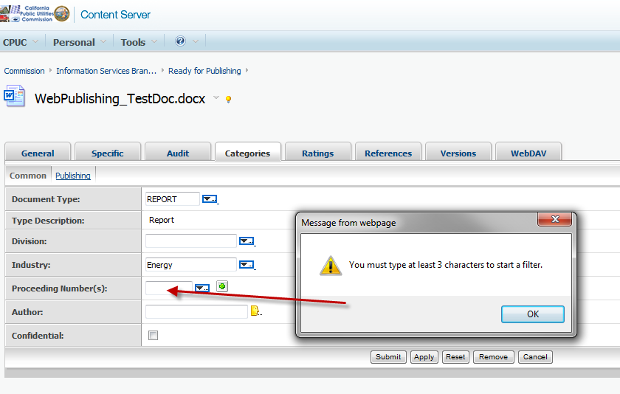
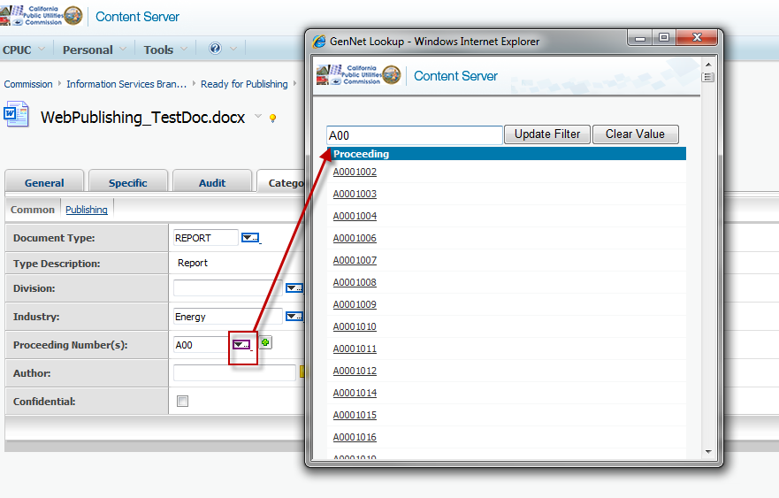
Once the results list is displayed, you can select the proceeding number from the lookup list by “clicking” on the desired hyperlink.
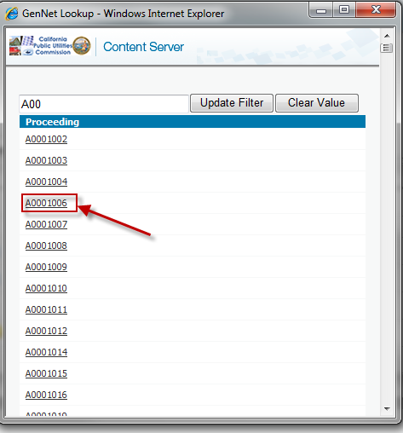
You can add/remove proceeding numbers by using the “plus” or “minus” sign buttons, as shown below:
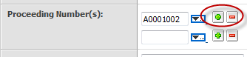
If required, the plus sign will allow you to enter multiple proceeding numbers.

Although author is also an optional field, it is recommended that you choose an author for your document.
In order to choose an author, you must select the author name from the look up list.
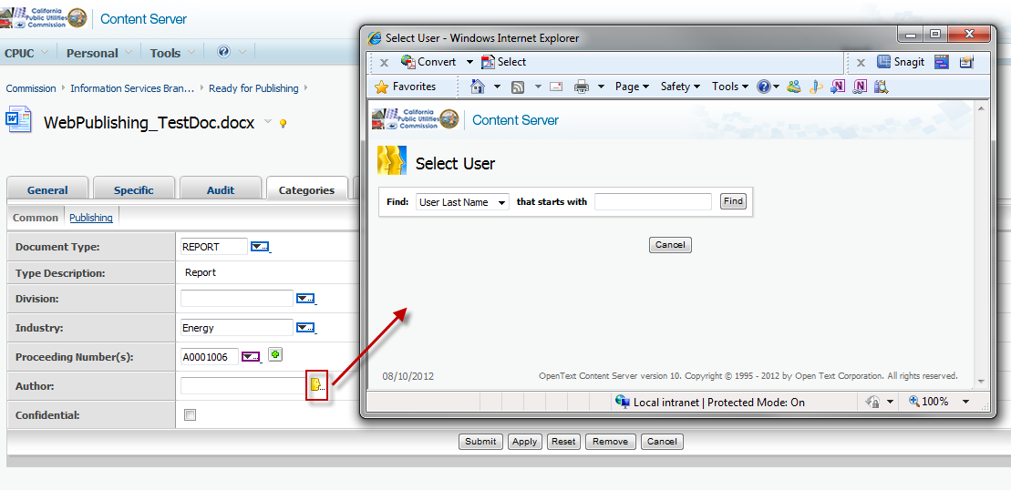

You may select a user by doing a look up based on the user’s last name, first name, log-in, e-mail, or group name
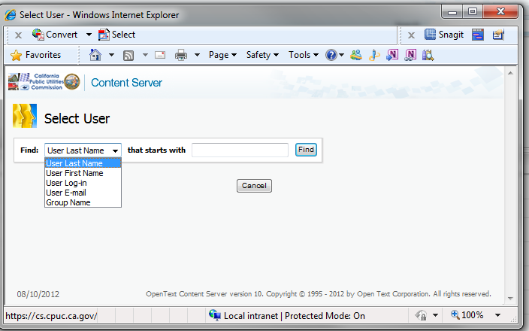
Once the user is found, you can select this user by clicking on “Select”
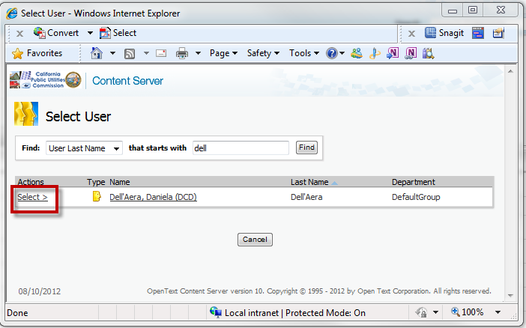

When complete, make sure you select “Apply”!
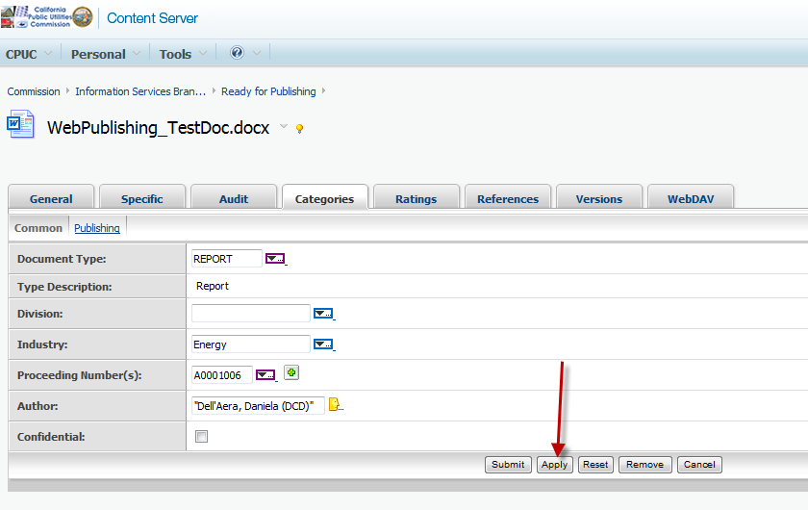

You are now ready to move to the next section – “Filling out the Publishing Category”.

Step 4: Fill out the “Publishing” Category
After filling out the “Common” category and selecting “Apply”, click on the “Publishing” tab and fill out that category.

Remember that the “Publishing Date” is the only required field under the “Publishing” category tab.

This date field, as well as the “Meeting Date” field, offers a visual calendar to assist you on selecting an appropriate date. “Publishing Time” uses a 24-hour clock (also known as military time).

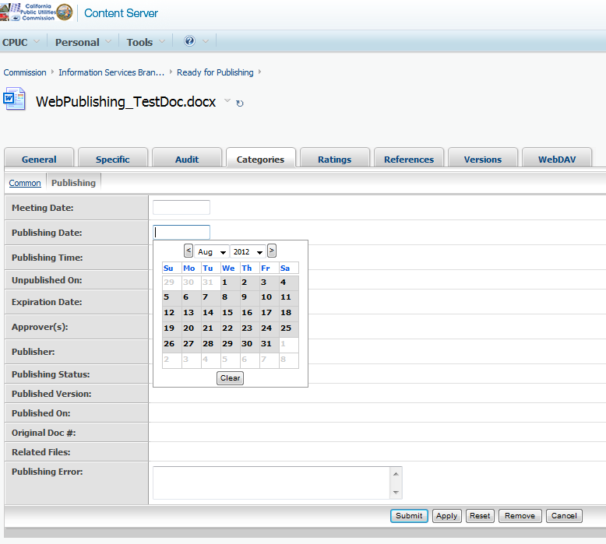

When complete, make sure you click on the “Apply” button, and then the “Submit” button. You are now done setting the categories of the Document and it has the information needed to be web published. Next step is to publish it.

Note: If your document requires an “Approver” to review it before publishing it, please go to the next step (Step 5) of this document. Otherwise, please skip to “Step 6”.

Step 5: Publishing a Document with an Approver (OPTIONAL STEP)
Use the “Approver” look up to select the name of the person (or the group name) who will approve your document for publishing.

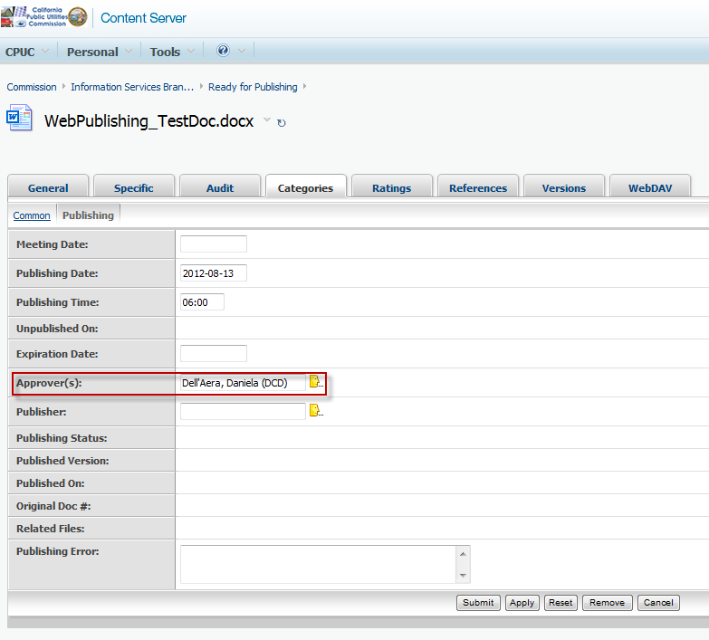

When complete, make sure you click on the “Apply” button, and then the “Submit” button.

From the Document function drop down, select ‘Publish to Website”. This will start the approval process workflow, which will generate an email notification to the approver name you selected above.

Within approximately 15 minutes, the approver will receive an email notification that a document needs his/her approval in order to be published. The approver needs to use the circled link to go to the approval screen.

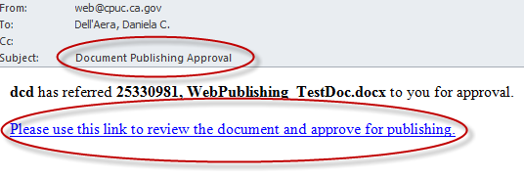

Note: If the document is not approved or rejected within approximately 30 minutes of the “approval request”, the approver will receive a “Document Late for Publishing” email notification.

Once you click on the link provided on the email, you will be presented with the following “Approval” screen:

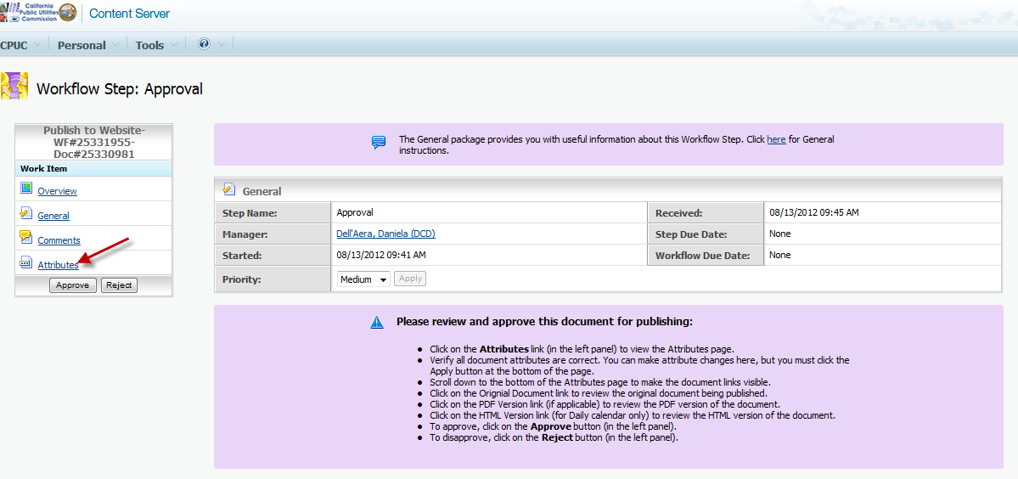

Upon selecting the “Attributes” option on the left side of the screen, you will be able to view all the attributes associated with this document, including the contents of the document itself.

After reviewing the document’s attributes, you can either “Approve” or “Reject” the publishing of this document.

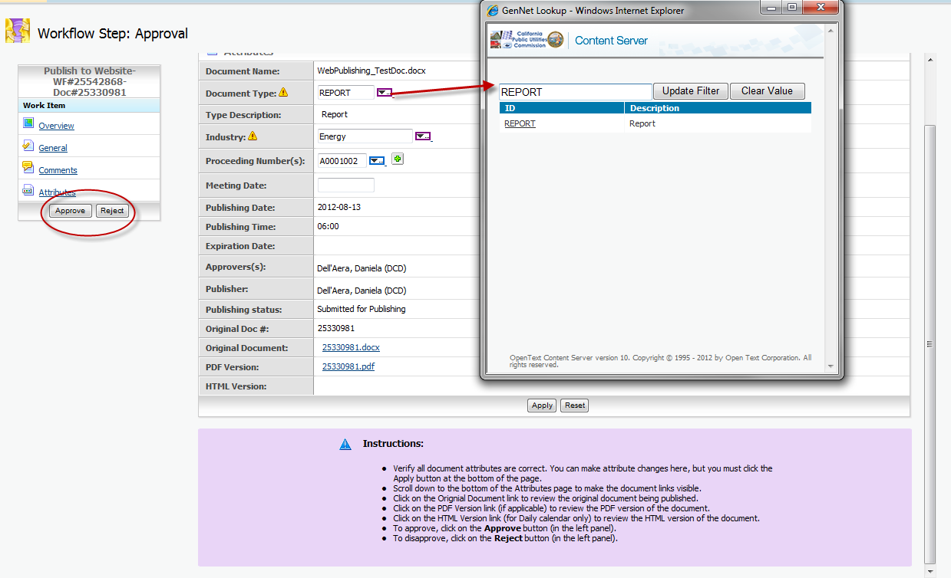

To Approve/Reject: Select one of the buttons on the left hand side of the screen (circled in red for illustration purposes).

The publisher will receive the following system generated emails:
- Notification that the document was approved or disapproved.
- Notification that the document was published.

Step 6: Web Publishing a Single Document
Now you are ready to publish the Document.

From the Document function drop down, select “Publish to Website”.

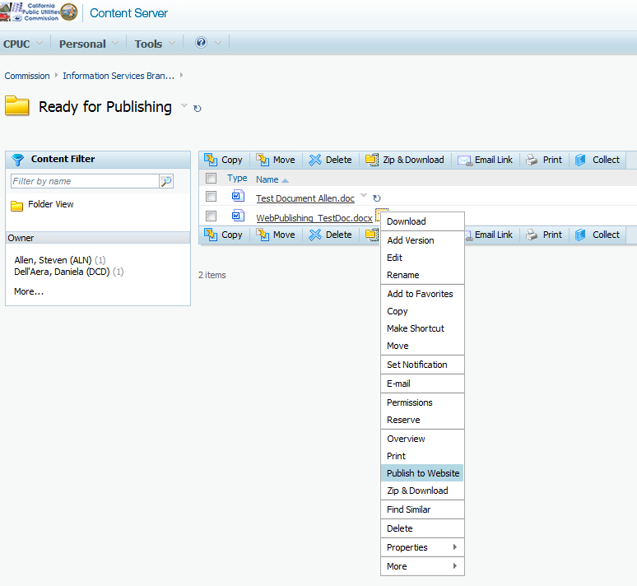

Your Document is now scheduled to be published on the date/time you specified. You will notice a “red checkmark” on the left of the document icon, illustrating that this document is now “checked out” and can no longer be edited. A PDF version of the document will be automatically generated at this point.

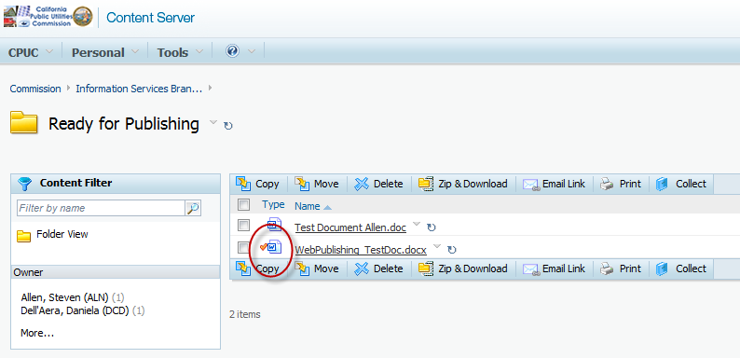

After a few minutes, the web publishing process will move your document and its system generated PDF counterpart to the Published Documents Folder, under the following path:

“Commission-> Published Documents -> [Published Year] -> [Document Type]”

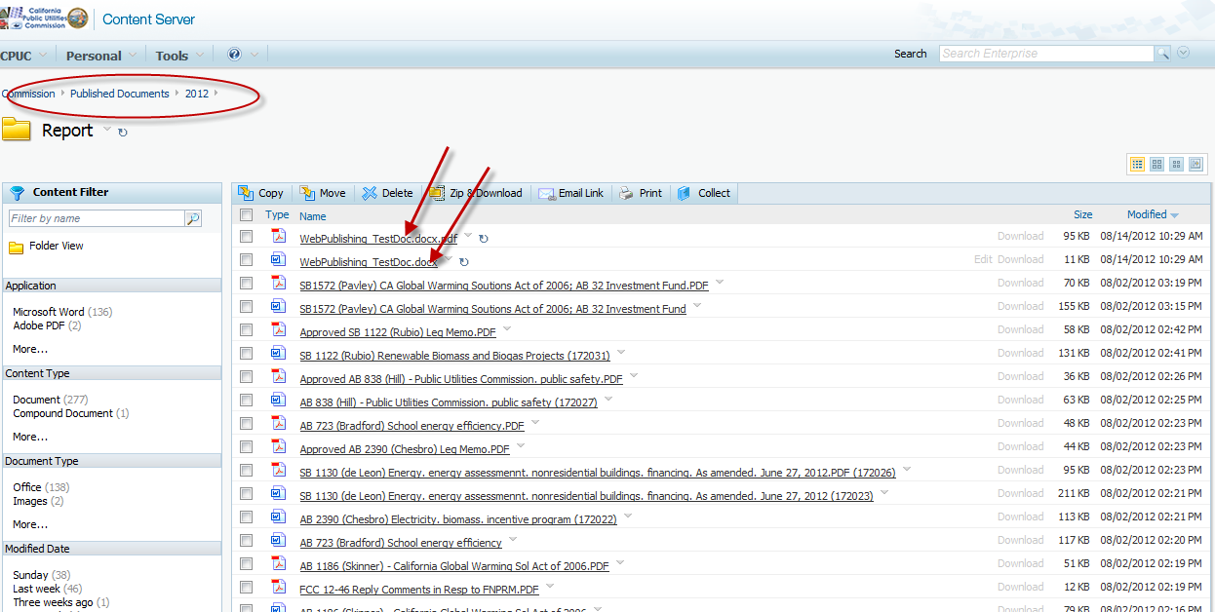

As part of the web publishing process, you will receive a system generated email notification that the document was published. You can distribute the link provided on this email to outside parties (this is the link to view documents on the public site).

